**Programming Fundamentals**

**Lab Report**

**Lab 12**



|  |  |
| --- | --- |
| Group Members Name & Reg #: | **Muhammad Haris Irfan**  **(FA18-BCE-090)** |
|  |  |
| Class | Programming Fundamentals CSC103 (**BCE-2B**) |
| Instructor’s Name | Dilshad Sabir |

**In Lab Tasks**

**Question no: 1**

Write a C Program that does the following:

1. Declares a C-Structure called ‘**car**’.

2. It should contain the following elements

a) A char array of size 20 to hold the **make** of the car e.g. Suzuki.

b) A char array of size 20 to hold the **model** of the car e.g. Alto

c) An integer **capacity** to store the seating capacity.

d) A floating-point number to hold the **weight** of the empty vehicle.

3. Then declare 3 variables of this type of structure.

4. Let the user populate the elements of these variables.

5. Print these structures

**Solution:**

The Code for the following code is attached below,

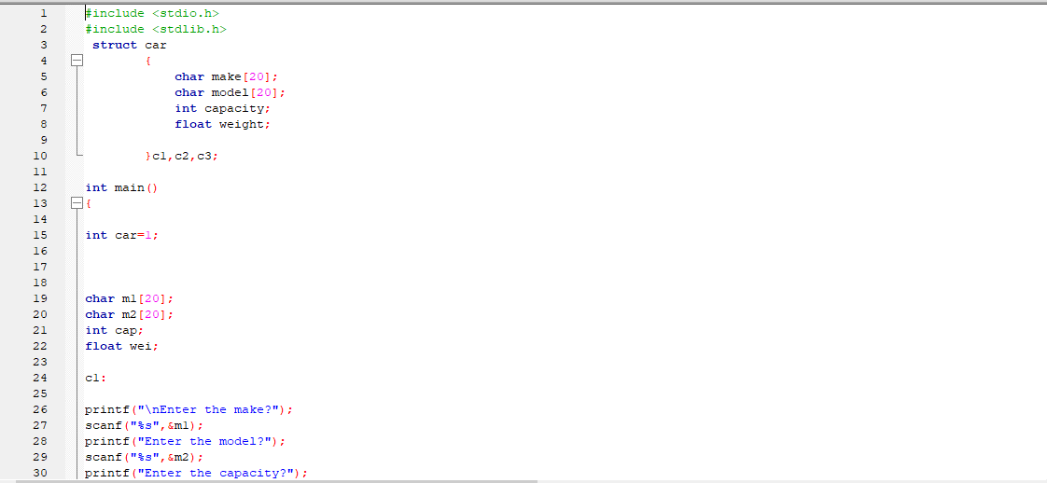

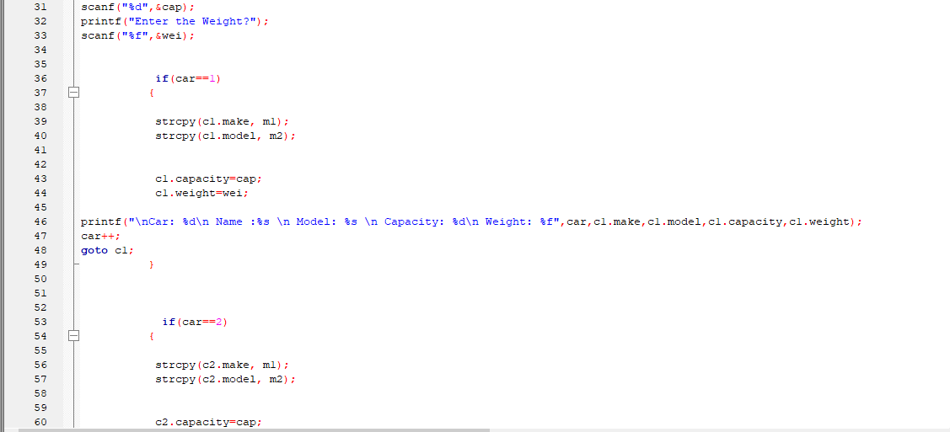

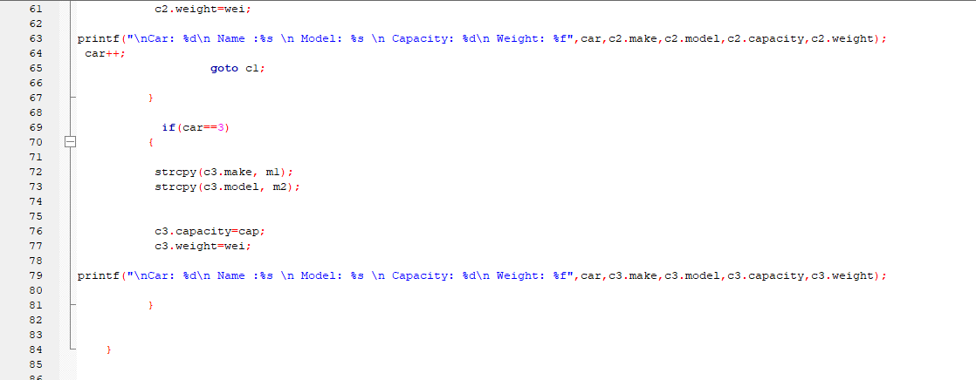

The Result of the following code is attached below:

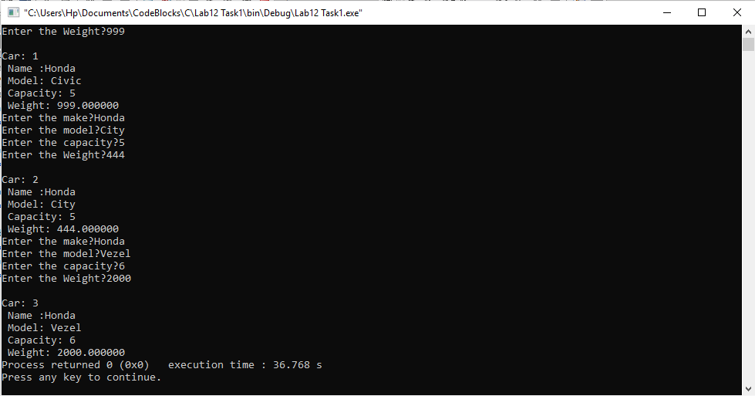

-------------------------------

**Question no: 2(A)**

Write a C program that declares an array of structures of type ‘**car**’ from previous example, and asks the user to fill in the elements. Once all the structures have been initialized, the program should present a menu to the user so that he can print a certain structure, or modify its elements.

Solution

The code is shown below for the given program,

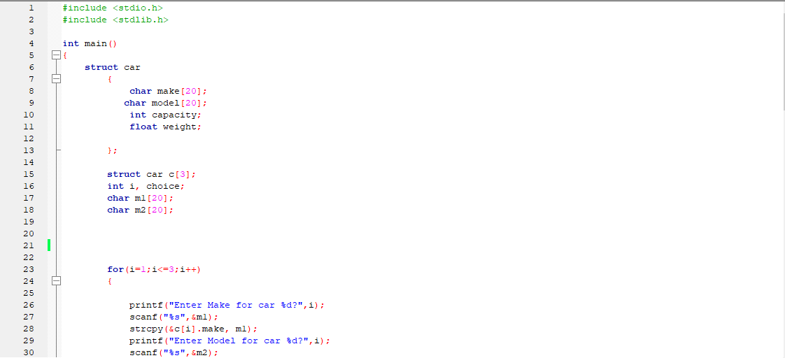

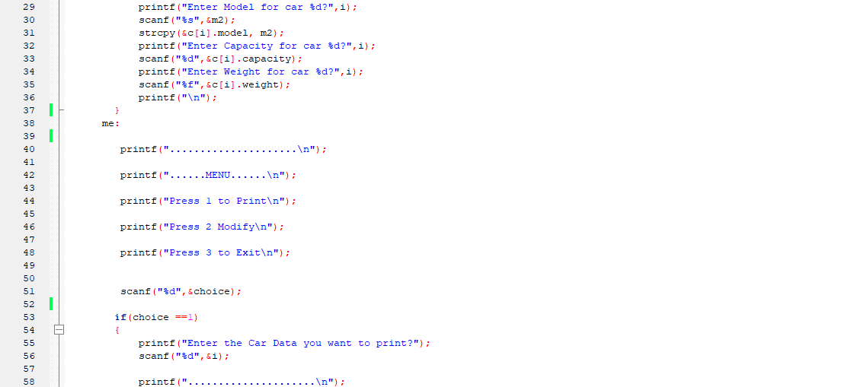

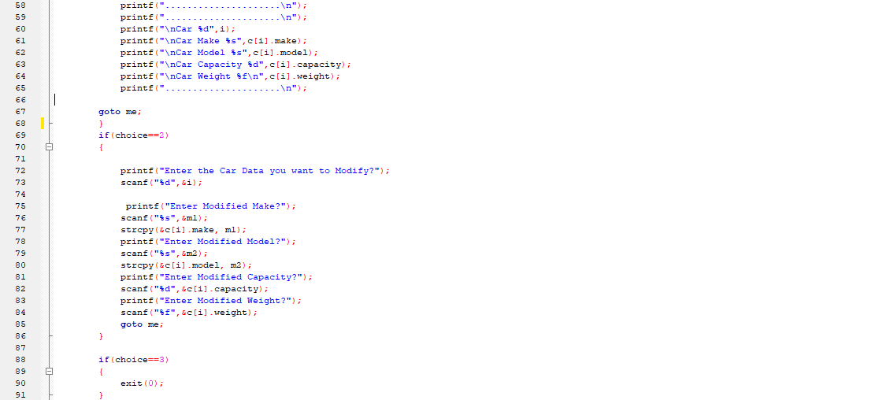

The Result of the following code is attached below:

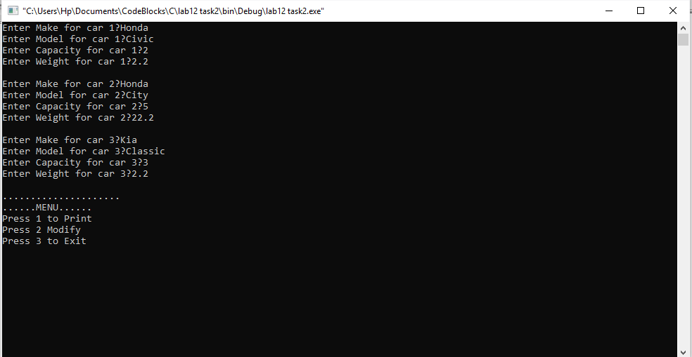

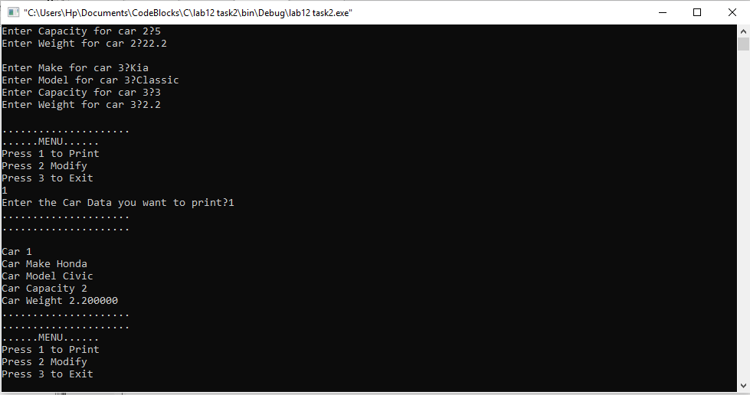

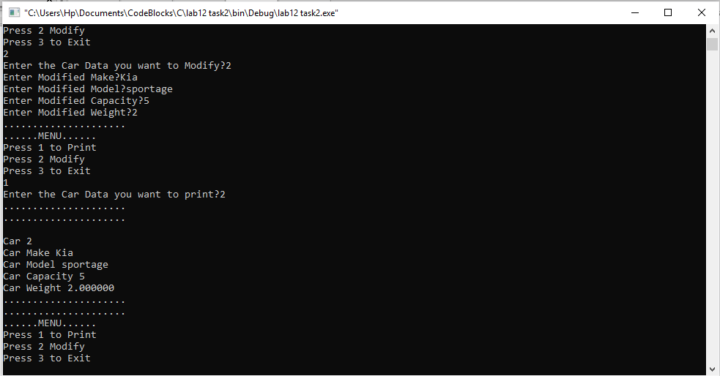

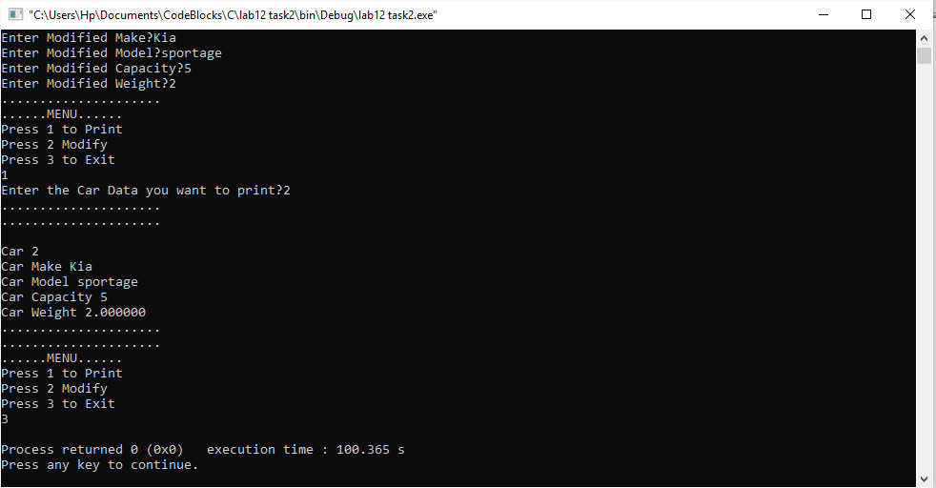

-------------------------------

**Question no: 2(B)**

There is a structure called employee that holds information like employee code, name, date of joining. Write a program to create an array of the structure and enter some data into it. Then ask the

user to enter current date. Display the names of those employees whose tenure is 3 or more than 3 years according to the given current date.

Solution

The code is shown below for the given program**,**

~~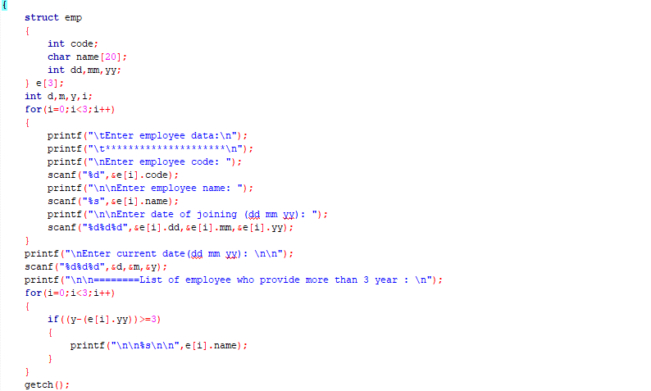~~

The Result of the following code is attached below:

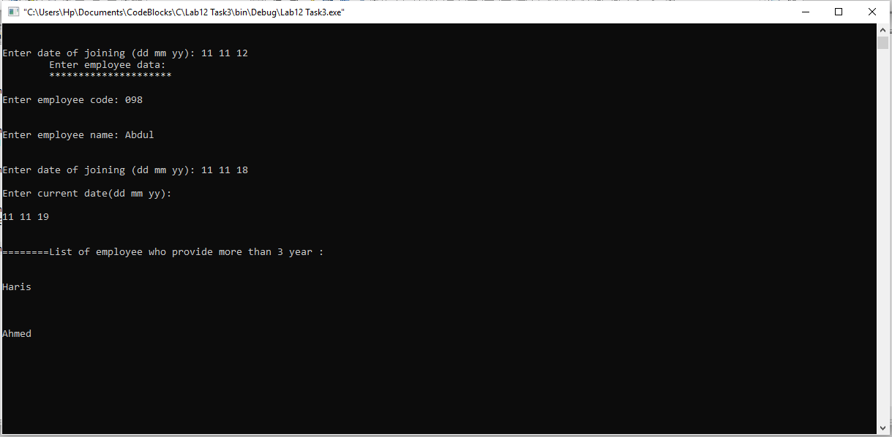



------------------------------

THE END

*there was no post lab for this lab.